
Aranmore Catholic College
Year 11 Human Biology
Cells & Tissues

DO NOT WRITE ON THE TEST PAPER
Part A: Multiple Choice 20 marks

- During mitosis a chromosome is attached to the spindle by the;
  - Centrosome
  - Chromatid
  - Centromere
  - Centricle

- The blue print for protein synthesis is carried to the site of the synthesis by?
  - DNA
  - Transfer RNA
  - Messenger RNA
  - ATP

- Animal cells contain organelles. The organelle essential for normal cell division is;
  - the mitochondria
  - a Golgi body
  - the nucleus
  - the DNA

- Mitochondria concentration will be the highest in which of these cells?
  - Nerve cells
  - Secretory cells
  - Muscle cells
  - Red blood cells

- A series of interconnecting canals transporting fluids has been observed in the cell. These canals are called?
  - Lysosomes
  - Endoplasmic reticulum
  - Centrioles
  - Mitochondria

- A group of cells similar in structure and function is a/an;
  - organ
  - tissue
  - system
  - organism

- If a mixture of proteins and glucose is placed in a bag immersed in water, the glucose will diffuse through the bag but the protein will not. This is because the bag is:
  - a living membrane
  - selectively permeable
  - permeable only to molecules of inorganic origins
  - impermeable to all except large organic molecules

- Colchicine is a chemical that inhibits the formation of spindles. This would affect a cell during:
  - growth
  - ageing
  - cell division
  - all of its normal functions

- Which of the following combinations of lenses will give the greatest magnification in a microscope?
  - x10 ocular lens x40 objective lens
  - x5 ocular lens x10 objective lens
  - x10 ocular lens x10 objective lens
  - x5 ocular lens x5 objective lens

- It is found that a specialised cell conducts impulses but performs no other function. Such a cell would best be classified as:
  - a muscle cell
  - a glandular cell
  - an epithelial cell
  - a nerve cell

- How are ADP and ATP related?
  - They are identical except ADP has more energy.
  - ADP has one more phosphate group and less stored energy than ATP.
  - They are opposite processes
  - ATP has one more phosphate group and less stored energy than ADP

- Which of the following is the main characteristic feature of epithelial tissue?
  - Usually composed of large amounts of extra cellular material
  - Blood vessels are located in this tissue
  - Usually consists of multi-layers of cells
  - One of its surfaces is usually exposed either to the exterior of the body or to the cavity of a hollow organ.

- What do cells in the human body use as their primary source of energy?
  - Amino acids
  - Glucose
  - Fatty acids
  - Sucrose

- Smooth muscle tissue:
  - is in the walls of the arteries
  - is attached to the skeleton
  - contains many nuclei in each cell
  - forms the wall of the heart

- Mitotic division of a cell containing a diploid (2N) nucleus normally produces:
  - 2 cells, each with a N nucleus
  - 2 cells, each with a 2N nucleus
  - 4 cells, each with a N nucleus
  - 4 cells, each with a 2N nucleus

- The organelles in the cell which are responsible respectively for protein synthesis, energy production and secretion are:
  - ribosomes, Golgi bodies, endoplasmic reticulum
  - Golgi bodies, ribosomes, mitochondria
  - Ribosomes, mitochondria, Golgi bodies
  - Mitochondria, ribosomes, endoplasmic reticulum

- The type of tissue lining the digestive tract is:
  - epithelial tissue
  - connective tissue
  - muscular tissue
  - contractile tissue

- The concentration of lactic acid in a muscle is found to be greater after exercise than before. The reason for this is:
  - insufficient oxygen in the muscle
  - an excess of carbon dioxide in the muscle
  - insufficient glucose in the muscle
  - a high rate of aerobic respiration

- The energy in respiration is utilised for many processes. One process not requiring energy is:
  - active transport
  - protein synthesis
  - muscle contraction
  - combination of oxygen and haemoglobin

- Which of the following statements about caner is incorrect?
  - Viruses can cause cancer
  - Our immune system protects us against cancer
  - The incident of cancer in developed countries is decreasing
  - Leukaemia is a cancer of tissue that forms blood cells

Part B: Short Answers 30 marks

DO NOT WRITE ON THE TEST PAPER

QUESTION 1 (Total 7 marks)

The diagram below refers to part a) of Question 1.

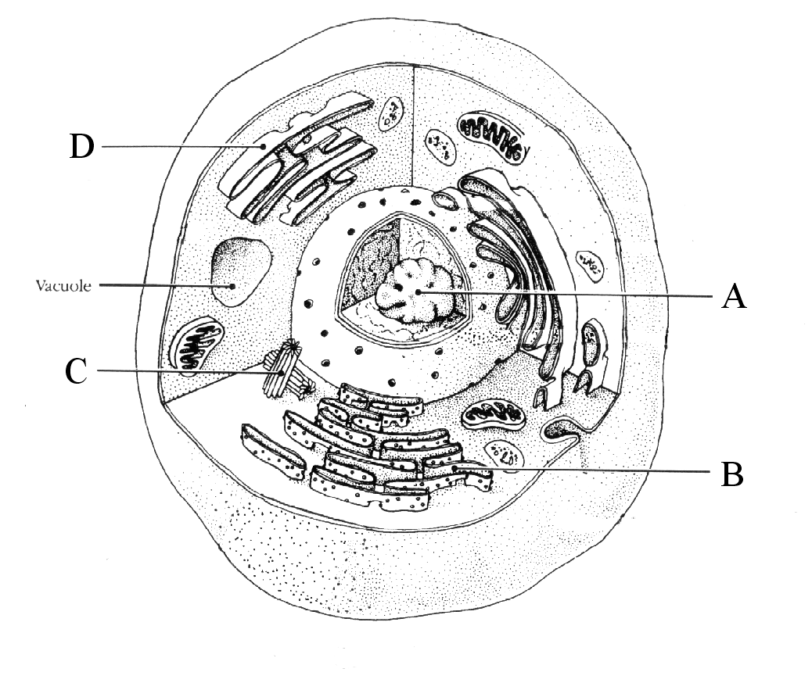
- In the spaces provided below, name the parts shown in the diagram of the cell.
A __________________________________ C __________________________________
B __________________________________ D __________________________________
(4)

- During exercise, skeletal muscle cells will be producing large amounts of energy for muscle contraction.

  - Name the process occurring in the cell to produce adenosine triphosphate (ATP) when oxygen is readily available.
(1)

  - Give the name of the organelle in which this process occurs.
(1)

- What other substances are produced during this process?
(1)

DO NOT WRITE ON THE TEST PAPER

QUESTION 2 (Total 10 marks)

The diagrams below show various stages of mitosis, they are in a jumbled order.
a) Underneath each diagram write the correct name of the phase.
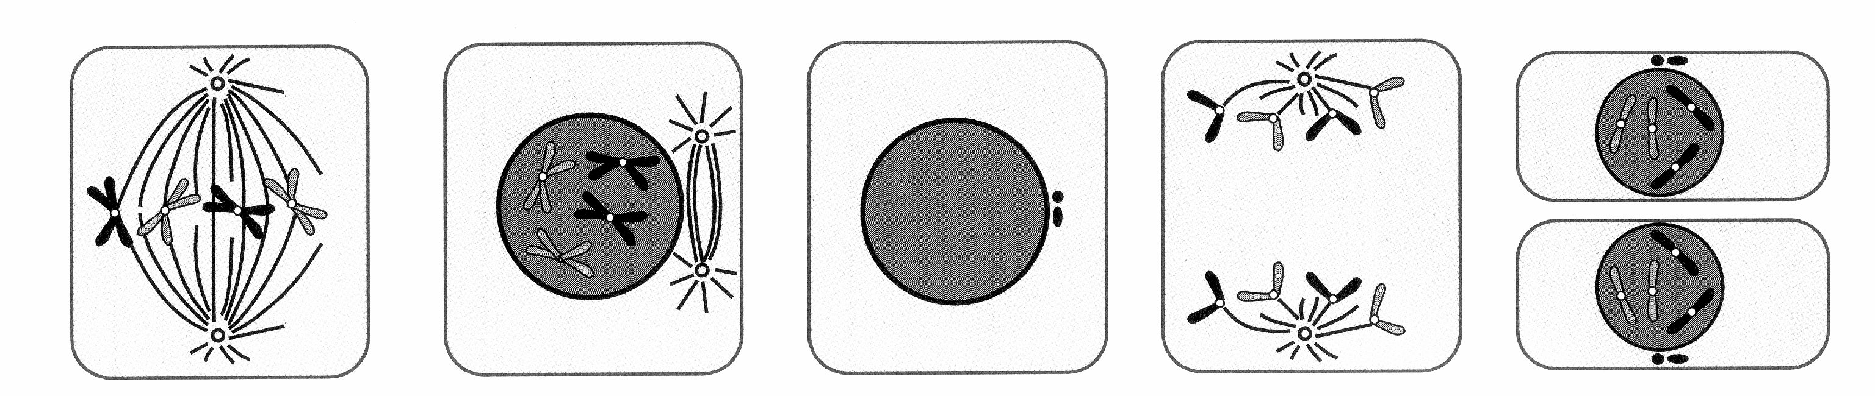

…………………. ……………… ……………… ………………. ………………
(5)

b) Complete the below table by placing the phases in order and explaining the
major events of each.
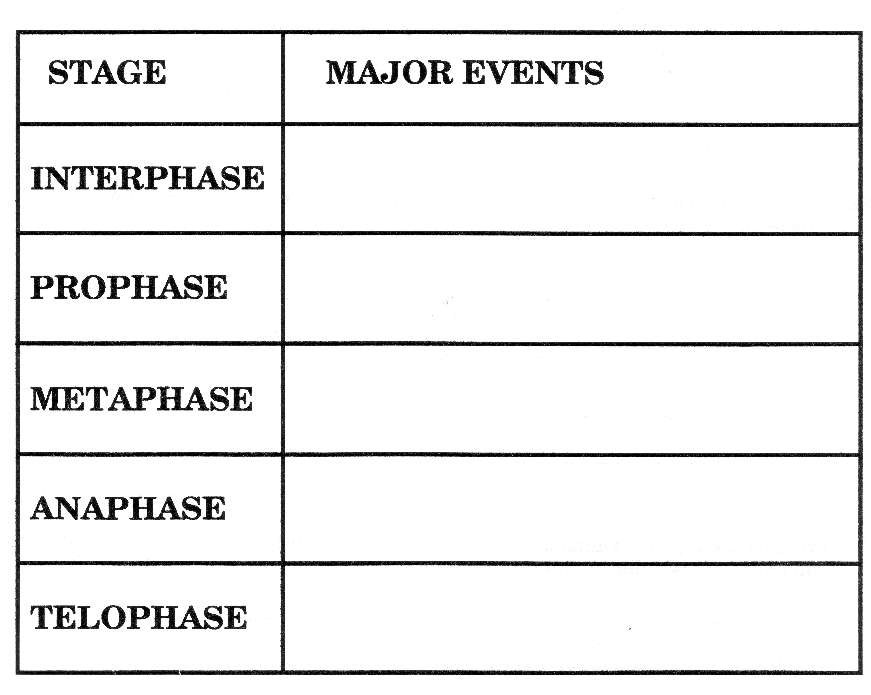

(5)
DO NOT WRITE ON THE TEST PAPER

QUESTION 3 (Total 6 marks)

Tissue Drawing | Type of Tissue | Where in the body is this tissue found?
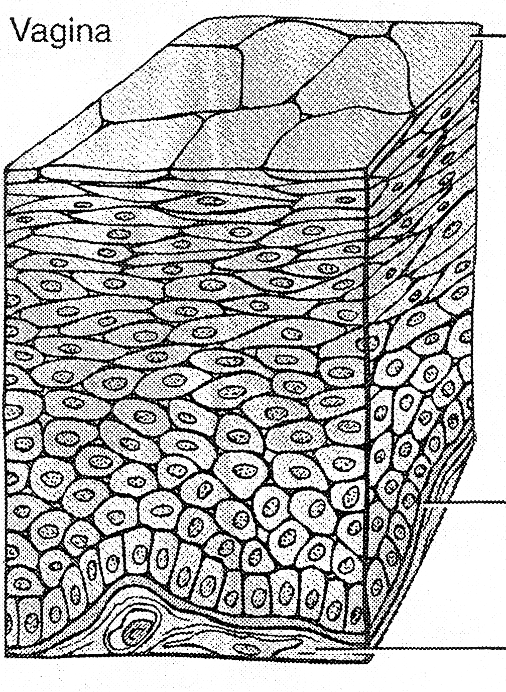

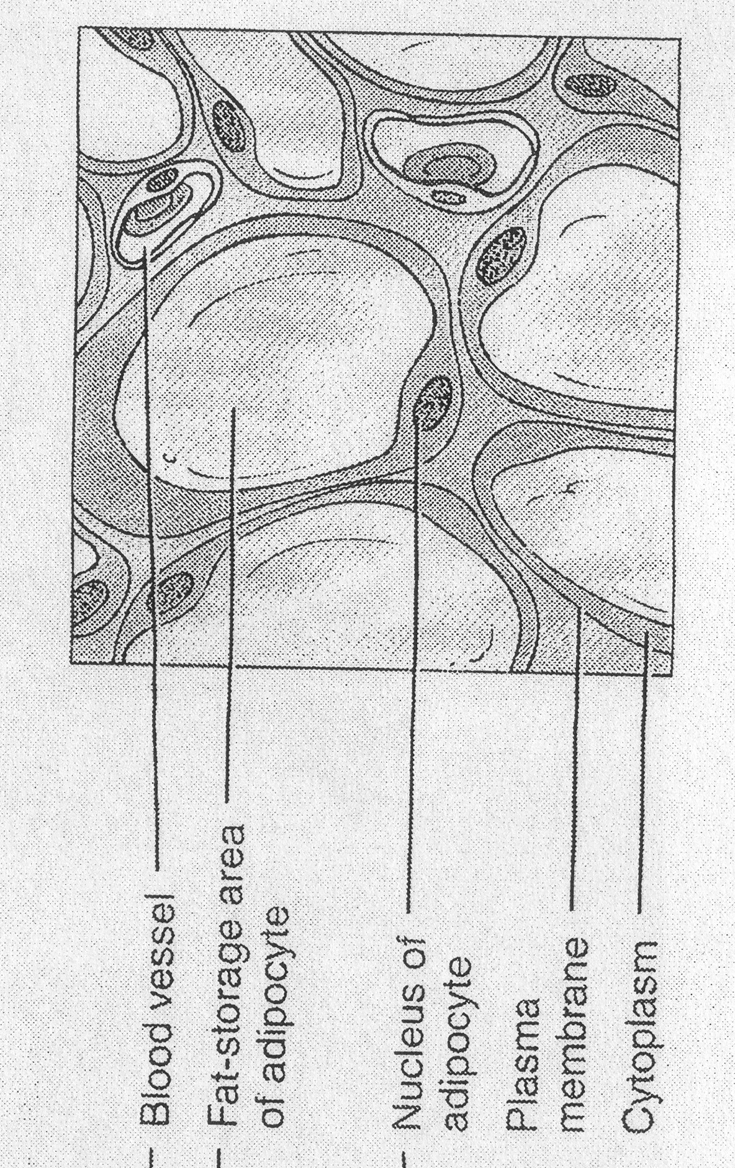

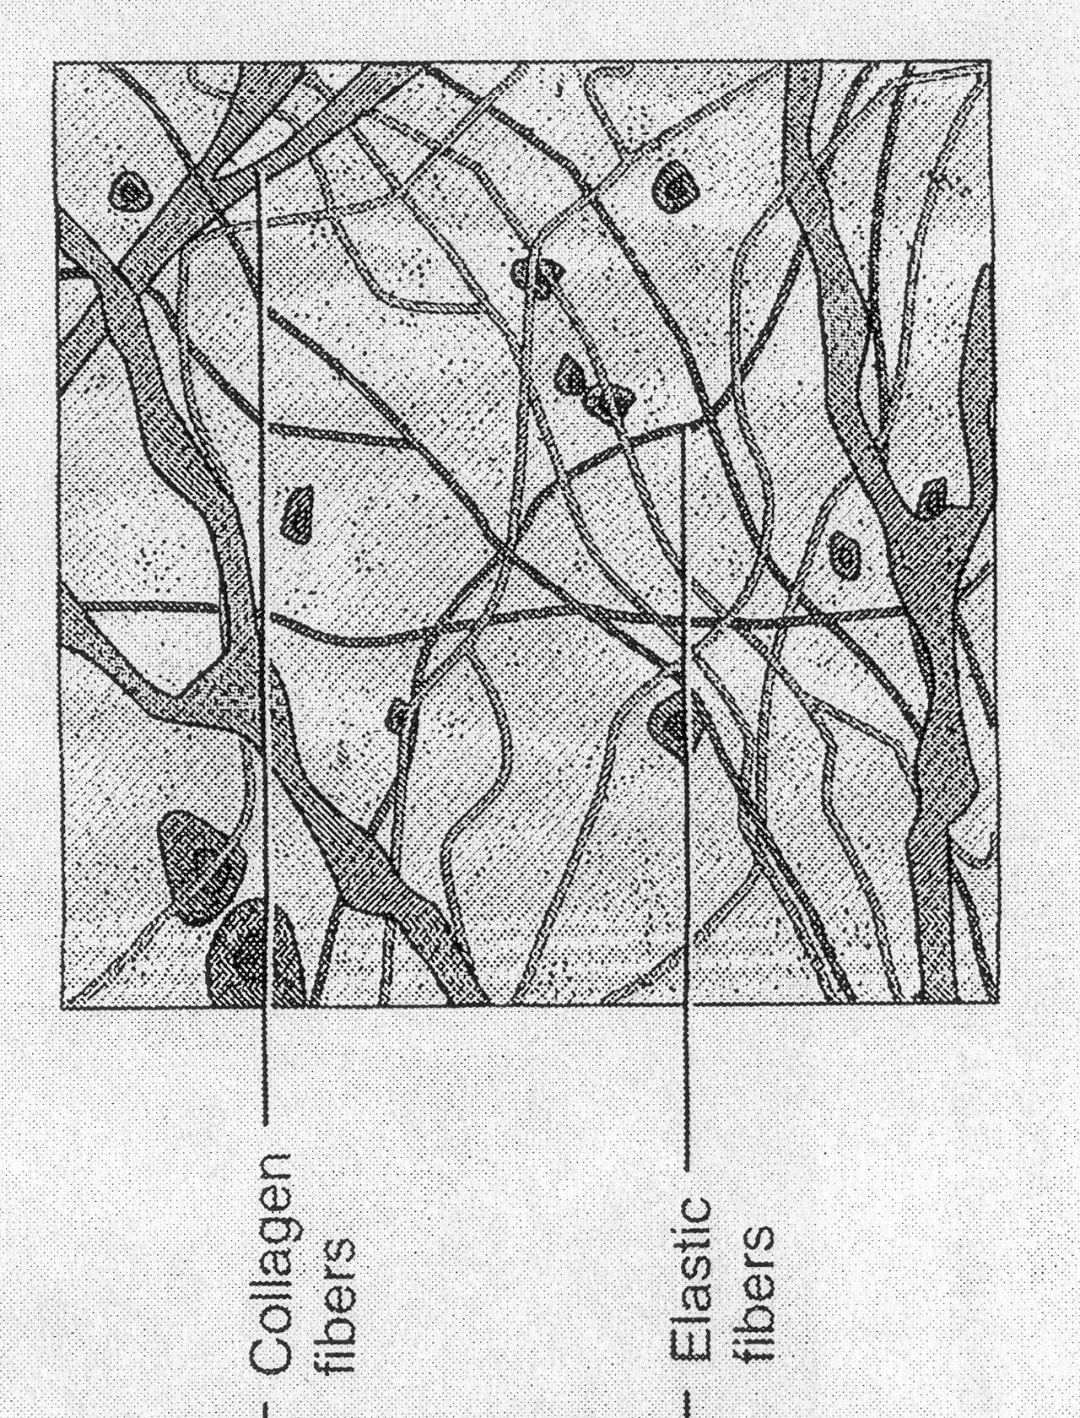

DO NOT WRITE ON THE TEST PAPER

QUESTION 4 (Total 7 marks)

A Scientist carried out an experiment to measure the effect of alcohol on people’s reaction time.

A group of 15 male University students of similar weight, height and age were given a non-alcoholic drink and were timed as to how long it took them to press a buzzer after seeing a red light.

The procedure was repeated with the same students with their reaction times being measured after they had drunk 1, 2 and 3 standard alcoholic drinks

      - State the hypothesis the scientist was testing in this experiment. (2)
      - In this experiment, what was the independent variable? (1)
      - What was the dependent variable in this experiment? (1)
      - Name four variables that were controlled in this experiment. (2)
      - What was the control in this experiment? (1)

